**S&P 500 Analysis**

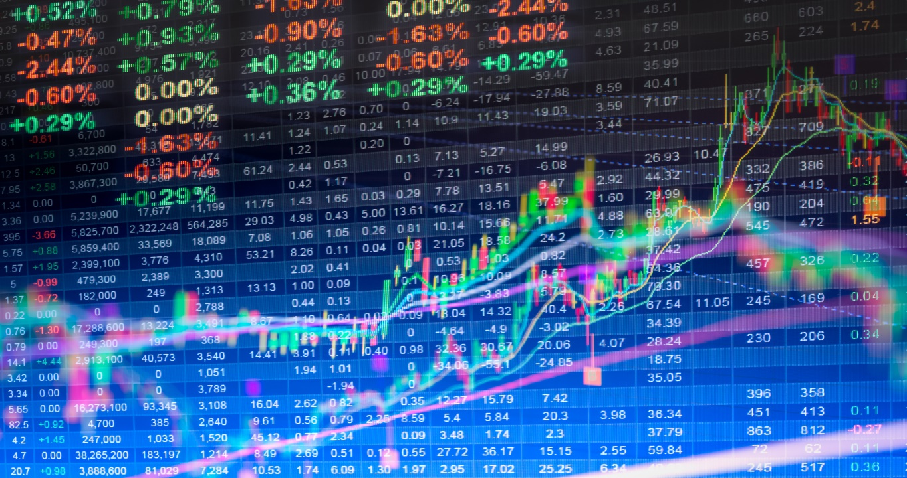

**DESCRIPTION:**

List of companies in the S&P 500 (Standard and Poor’s 500). The S&P 500 is a free-float, capitalization-weighted index of the top 500 publicly listed stocks in the US (top 500 by market cap). The dataset includes a list of all the stocks contained therein and associated key financials such as price, market capitalization, earnings, price/earnings ratio, price to book etc.

We have 4 datasets that includes all the information about the S&P 500:

* Index Performance- The index has returns of historic annualized average return from year 1928-2023. Also it has Annual Open , Close, High and Low.
* List of Companies-This Dataset includes all the information about the companies. For example, name, Ticker Symbol, industry, Date founded, Headquarters
* Weightage of Companies-This Dataset includes total weightage of a company in S&P 500. Also it includes percentage change, weightage percentage etc.
* Market Capitalization of Companies-This Dataset provides information about company’s total Market Capitalization in Trillion.
* The Later 3 Datasets are Relational Datasets

**BUSINESS PROBLEMS:**

* Analysis Year Close , High for the S&P 500
* Annual Percentage Change
* Companies with Highest Market Capitalization
* Sector Breakdown S&P 500
* Total Number of Companies , Sectors and Market Capitalization
* Companies Weightage in S&P 500
* Stock Price per Stock for every Company
* Company year of foundation and Headquarters

**TABLEAU DATABASE**

We uploaded all the Datasets into Tableau.

The tables Index Performance, List Of Companies, Market Capitalization are Related to each other therefore, we just joined the tables with common Column and formed our Database for Tableau Visualization.

**Findings for Business Problems:**

* The year close of S&P 500 from year 1994 to present year have always had upward trend
* The year open of S&P 500 from year 1994 to 1990 was constant but showed a sharp upward trend after that.
* The Annual % change for S&P have mostly been in the positive direction.
* The highest Market Cap in S&P is of Apple constituting of $2.12T followed by Microsoft with $1.78T
* Most Companies in S&P 500 belongs to IT sector i.e. around 27.9% followed by Healthcare and financials with 13.2% and 12.7%.
* We have a total of 504 companies in S&P 500 within 19 different sectors.
* The total Market Capitalization of S&P 500 is about $36.63 Trillion .
* Apple have the most weightage in S&P followed by Microsoft . Also Amazona and Nividia have almost same weightage .
* The highest Stock Price of a company in S&P 500 is of Nvr Inc of $6260 followed by Booking holidays i.e. 3019
* We see that a lot of companies were founded in 1957.

**Dashboard**

